Chapter
Managing Projects

Discussion Questions
1. There are many possible answers. Project management is needed in large construction jobs, in implementing new information systems, in new product development/marketing, in creating a new assembly line, and so on.
2. Project organizations make sure existing programs continue to
run smoothly while new projects are successfully completed.
3. The three phases involved in managing a large project are planning, scheduling, and controlling.
4. PERT and CPM help answer questions relating to which task elements are on (or likely to be on) the critical path and to proba-ble completion times for the overall project. Some specific questions include:
- When will the entire project be completed?
- Which are the critical activities or tasks in the project; that is, the activities that will delay the entire project if completed behind schedule?
- Which are the noncritical activities; that is, those that can run behind schedule without delaying the whole project? How far behind schedule can these activities run without disrupting the completion time?
- What is the probability that the project will be completed
by a specific date?
- At any particular date, is the project on schedule, behind schedule, or ahead of schedule?
- On any given date, is the money spent equal to, less than, or greater than the budgeted amount?
- Are there enough resources available to finish the project
on time?
- If the project is required to be finished in a shorter amount of time, what is the least-cost way to accomplish this?
5. WBS is a hierarchial subdivision of effort required to achieve an objective. It defines a project by breaking it down into manage-able parts and even finer subdivisions.
6. A Gantt chart is a visual device that shows the duration of tasks in a project. It is a low-cost means of ensuring that (1) all activities are planned for, (2) their order of performance is planned for, (3) the activity times are recorded, and (4) the overall project time is developed.
7. The difference between AOA and AON is that activities are shown on arrows in the former and on the node in the latter. We primarily use AON in this chapter.
8. Any late start or extension of an activity on the critical path will delay the completion of the project.
9. To crash an activity, the project manager would pay money
to add resources (overtime, extra help).
10. Activity times used in PERT are assumed to be described by a Beta probability distribution. Given optimistic (a), pessimistic (b), and most likely (m), completion times, average or expected time is given by:
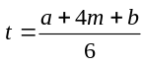
and the variance by:
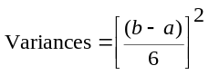
11. Early start (ES) of an activity is the latest of the early finish times of all its predecessors. Early finish (EF) is the early start of an activity plus its duration. Late finish (LF) of an activity is the earliest of the late start times of all successor activities. Late start (LS) of an activity is its late finish less its duration.
12. The critical path is the shortest time possible for the completion of a series of activities, but that shortest time is the longest path through the network. Only the longest path allows time for all
activities in the series; any smaller amount will leave activities
unfinished.
13. Dummy activities have no time duration. They are inserted into a AOA network to maintain the logic of the network, such as when two activities have exactly the same beginning and ending events. A dummy activity is inserted with one of them so that the computer software can handle the problem.
14. They are (1) optimistic time estimate (a), an estimate of the minimum time an activity will require; (2) most likely time estimate (m), an estimate of the normal time an activity will require; and (3) pessimistic time estimate (b), an estimate of the maximum time an activity will require.
15. No. In networks, there is no possibility that crashing a non-critical task can reduce the project duration. Only critical tasks offer the possibility of reducing path length. However, other criteria for crashing may exist: for instance, skills required in one of the activities may also be needed elsewhere.
16. Total PERT project variance is computed as the sum of the variances of all activities on the critical path.
17. Slack: the amount of time an activity can be delayed and not affect the overall completion time of the whole project. Slack can be determined by finding the difference between the earliest start time and the latest start time, or the earliest finish time and the lat-est finish time for a given activity.
18. If there are a sufficient number of tasks along the critical path, we can assume that project completion time is described by a
normal probability distribution with mean equal to the sum of the expected times of all activities on the critical path and variance equal to the sum of the variances of all activities on the critical path.
The fundamental assumption required is that the number of activities on the critical path is large enough that the mean of the sum of the Beta distributions is distributed approximately as the normal distribution.
19. Widely used project management software include TimeLine, MS Project, MacProject, Primavera, and PERTmaster.
Ethical Dilemma
Large projects with time/cost overruns are not uncommon situations in the world of project management. Why do MIS projects commonly sport 200–300% cost overruns and completion times twice that projected? Why do massive construction projects run so late and so over budget?
Students are expected to read about such projects and come up with explanations, especially related to ethics. In the case of MIS projects, long software development tasks are almost doomed to failure because of the changes in technology and staff that take place. It’s a necessity to break large projects down into smaller 3- to 6-month modules or pieces that are self-contained. This protects the organization from a total loss should the massive project never be completed.
In every case, quality project management means open communication, realistic timetables, good staff, and use of software like MSProject to build and maintain a schedule.
Bidding on a contract with a schedule that is not feasible may be unethical as well as poor business.
Active Model Exercise*
ACTIVE MODEL 3.1: Gantt Chart
1. Both A and H are critical activities. Describe the difference between what happens on the graph when you increase A vs.
increasing H.
When you increase H, it is the only task to change on the chart. However, when you increase A then all critical tasks
move to the right and the slack for the noncritical tasks
increases.
2. Activity F is not critical. By how many weeks can you increase activity F until it becomes critical?
6 weeks
3. Activity B is not critical. By how many weeks can you increase activity B until it becomes critical? What happens when B becomes critical?
1 week. Activity D also becomes critical.
4. What happens when you increase B by 1 more week after it becomes critical?
Activities A, C, and E become noncritical, and the project takes 1 additional week.
5. Suppose that building codes may change and, as a result, activity B would have to be completed before activity C could be started. How would this affect the project?
Activity B becomes critical, and the project takes 1
additional week.
* Active Model 3.1 appears on our Web sites
At www.pearsonglobaleditions.com/heizer and www.pearsonglobaleditions.com/myomlab

End-of-Chapter Problems
3.1 Some possible Level 3[(a)] and Level 4[(b)] activities for the house appear for each Level 2 activity below.

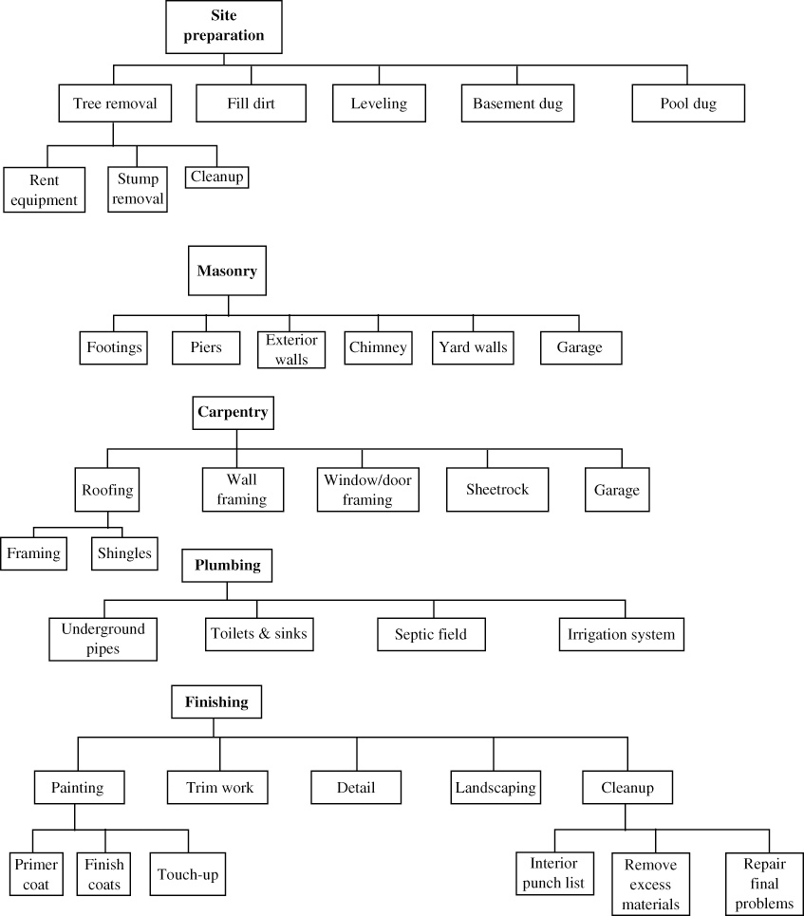

3.2 Here are some detailed activities to add to Mefford’s WBS:*
1.11 | Set initial goals for fundraising
1.12 | Set strategy including identifying sources and  solicitation
1.13 | Raise the funds
1.21 | Identify voters’ concerns
1.22 | Analyze competitor’s voting record
1.23 | Establish positions on issues
1.31 | Hire campaign manager and political advisor
1.32 | Get volunteers
1.33 | Hire a staff
1.34 | Hire media consultants
1.41 | Identify filing deadlines
1.42 | File for candidacy
1.51 | Train staff for audit planning
Students could make many other choices.
*Source: Modified from an example found in M. Hanna and W. Newman, Operations Management: Pearson, Upper Saddle River,
NJ (2001): p. 722.
3.3
3.4
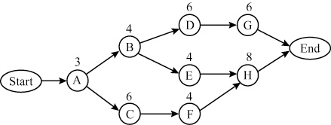
Critical path is A–C–F–H. Time = 21 days.
This is an AON network.

3.6 (a)
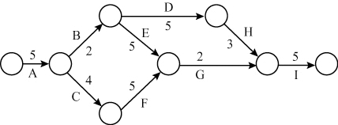
Critical path is A–C–F–G–I. Time = 21 days.
This is an AOA network.
3.5 The paths through this network are J–L–O, J–M–P,
J–M–N–O, K–P, and K–N–O. Their path durations are 23, 18, 22,
13, and 17. J–L–O is the critical path; its duration is 23.
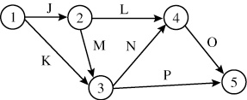
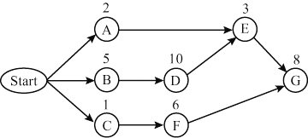
(b) Critical path is B–D–E–G
(c) Total project takes 26 days
(d)
Activity | Time | ES | EF | LS | LF | Slack | Critical
A | 2 | 0 | 2 | 13 | 15 | 13 | No
B | 5 | 0 | 5 | 0 | 5 | 0 | Yes
C | 1 | 0 | 1 | 11 | 12 | 11 | No
D | 10 | 5 | 15 | 5 | 15 | 0 | Yes
E | 3 | 15 | 18 | 15 | 18 | 0 | Yes
F | 6 | 1 | 7 | 12 | 18 | 11 | No
G | 8 | 18 | 26 | 18 | 26 | 0 | Yes

3.7 (a)
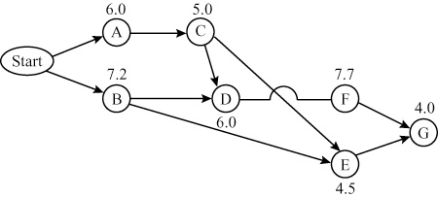

(b, c) There are four paths:
Path | Time (hours)
A–C–E–G | 19.5
B–D–F–G | 24.9
A–C–D–F–G | 28.7 (critical)
B–E–G | 15.7

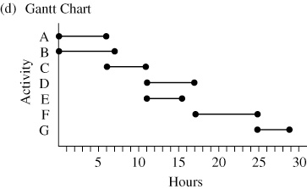

3.8
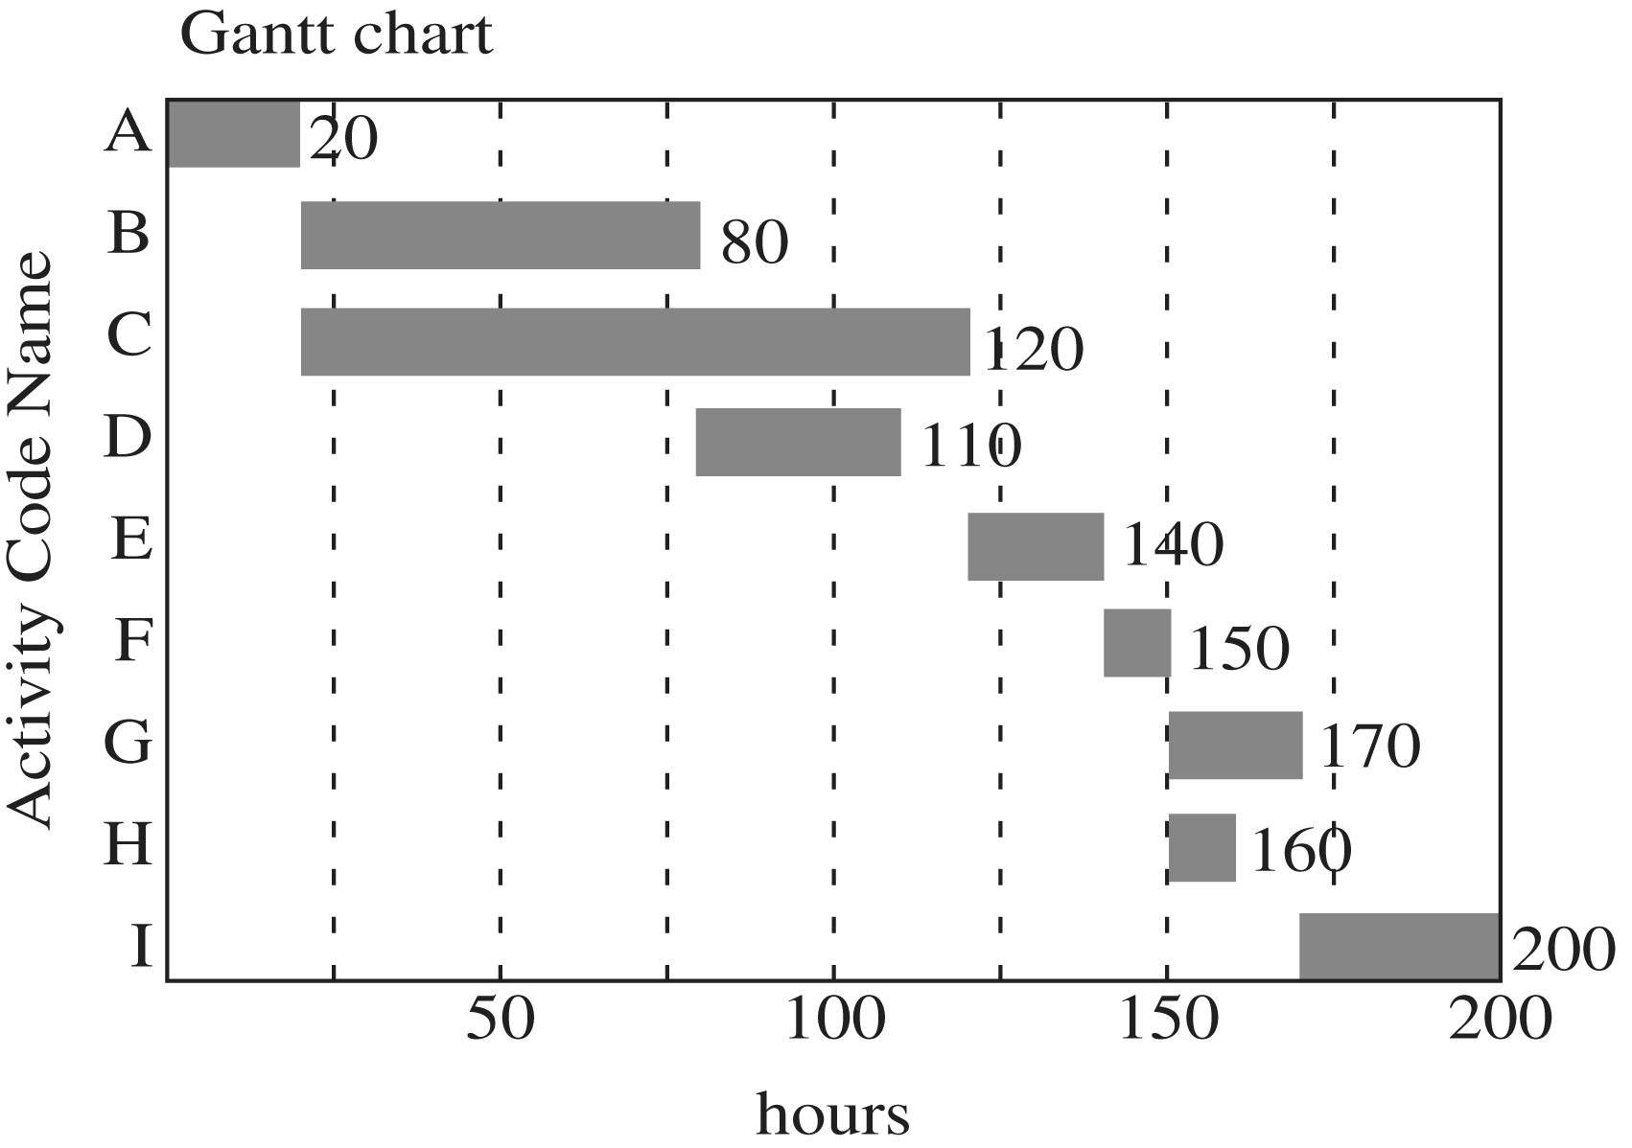
3.9 (a) AON network:
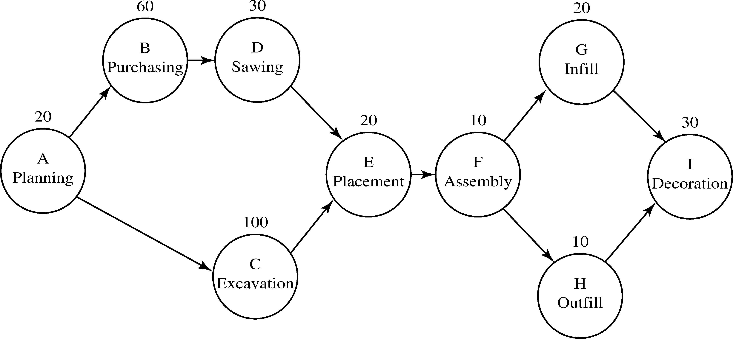
(b) AOA network:
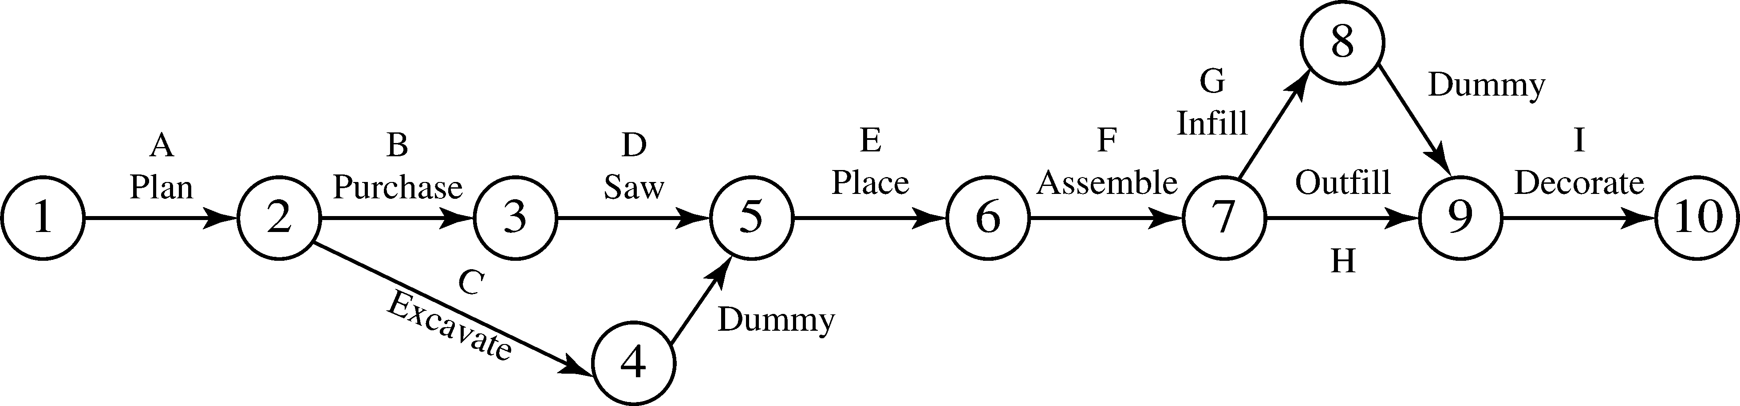

3.10
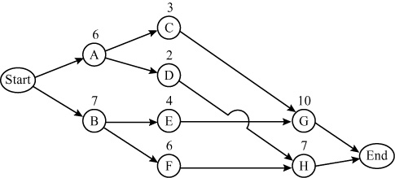
Note: Activity times are shown as an aid for Problem 3.11. They are not required in the solution to 3.10.

3.11
Activity | Time | ES | EF | LS | LF | Slack | Critical
A | 6 | 0 | 6 | 2 | 8 | 2 | No
B | 7 | 0 | 7 | 0 | 7 | 0 | Yes
C | 3 | 6 | 9 | 8 | 11 | 2 | No
D | 2 | 6 | 8 | 12 | 14 | 6 | No
E | 4 | 7 | 11 | 7 | 11 | 0 | Yes
F | 6 | 7 | 13 | 8 | 14 | 1 | No
G | 10 | 11 | 21 | 11 | 21 | 0 | Yes
H | 7 | 13 | 20 | 14 | 21 | 1 | No
The critical path is given for activities B, E, G.
Total project completion time is 21 weeks.
3.12 (a)

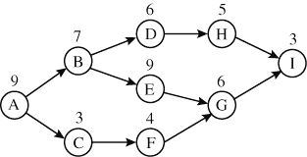

(b, c)
Task | Time | ES | EF | LS | LF | Slack
A | 9 | 0 | 9 | 0 | 9 | 0
B | 7 | 9 | 16 | 9 | 16 | 0
C | 3 | 9 | 12 | 18 | 21 | 9
D | 6 | 16 | 22 | 20 | 26 | 4
E | 9 | 16 | 25 | 16 | 25 | 0
F | 4 | 12 | 16 | 21 | 25 | 9
G | 6 | 25 | 31 | 25 | 31 | 0
H | 5 | 22 | 27 | 26 | 31 | 4
I | 3 | 31 | 34 | 31 | 34 | 0
Activities on the critical path: A, B, E, G, I
Project completion time = 34
3.13

Activity | a | m | b | 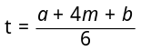 | 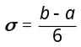 | Variance
A | 11 | 15 | 19 | 15 | 1.33 | 1.77
B | 27 | 31 | 41 | 32 | 2.33 | 5.44
C | 18 | 18 | 18 | 18 | 0 | 0
D | 8 | 13 | 19 | 13.17 | 1.83 | 3.36
E | 17 | 18 | 20 | 18.17 | 0.5 | 0.25
F | 16 | 19 | 22 | 19 | 1 | 1
3.14 (a)
Activity | a | m | b | Expected | Variance
A | 3 | 6 | 8 | 5.83 | 0.69
B | 2 | 4 | 4 | 3.67 | 0.11
C | 1 | 2 | 3 | 2.00 | 0.11
D | 6 | 7 | 8 | 7.00 | 0.11
E | 2 | 4 | 6 | 4.00 | 0.44
F | 6 | 10 | 14 | 10.00 | 1.78
G | 1 | 2 | 4 | 2.17 | 0.25
H | 3 | 6 | 9 | 6.00 | 1.00
I | 10 | 11 | 12 | 11.00 | 0.11
J | 14 | 16 | 20 | 16.33 | 1.00
K | 2 | 8 | 10 | 7.33 | 1.78
(b, c)
Activity | Time | ES | EF | LS | LF | Slack | Critical
A | 5.83 | 0.00 | 5.83 | 7.17 | 13.00 | 7.17 | No
B | 3.67 | 0.00 | 3.67 | 5.33 | 9.00 | 5.33 | No
C | 2.00 | 0.00 | 2.00 | 0.00 | 2.00 | 0.00 | Yes
D | 7.00 | 2.00 | 9.00 | 2.00 | 9.00 | 0.00 | Yes
E | 4.00 | 9.00 | 13.00 | 9.00 | 13.00 | 0.00 | Yes
F | 10.00 | 13.00 | 23.00 | 13.00 | 23.00 | 0.00 | Yes
G | 2.17 | 13.00 | 15.17 | 15.83 | 18.00 | 2.83 | No
H | 6.00 | 23.00 | 29.00 | 23.00 | 29.00 | 0.00 | Yes
I | 11.00 | 15.17 | 26.17 | 18.00 | 29.00 | 2.83 | No
J | 16.33 | 2.00 | 18.33 | 20.00 | 36.33 | 18.00 | No
K | 7.33 | 29.00 | 36.33 | 29.00 | 36.33 | 0.00 | Yes
The critical path is given by activities C, D, E, F, H, K. Average project completion time is 36.33 days.
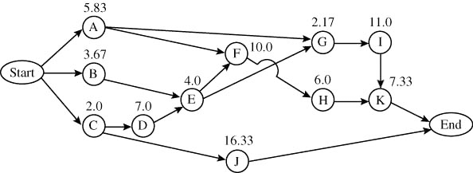

(d) Expected completion time for the project is 36.33 days. Project variance = Sum of variances of activities on critical path = 0.11 + 0.11 + 0.44 + 1.78 + 1.00 + 1.78 = 5.22. Standard deviation = 2.28
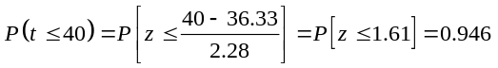
3.15 (a) AON diagram of the project:
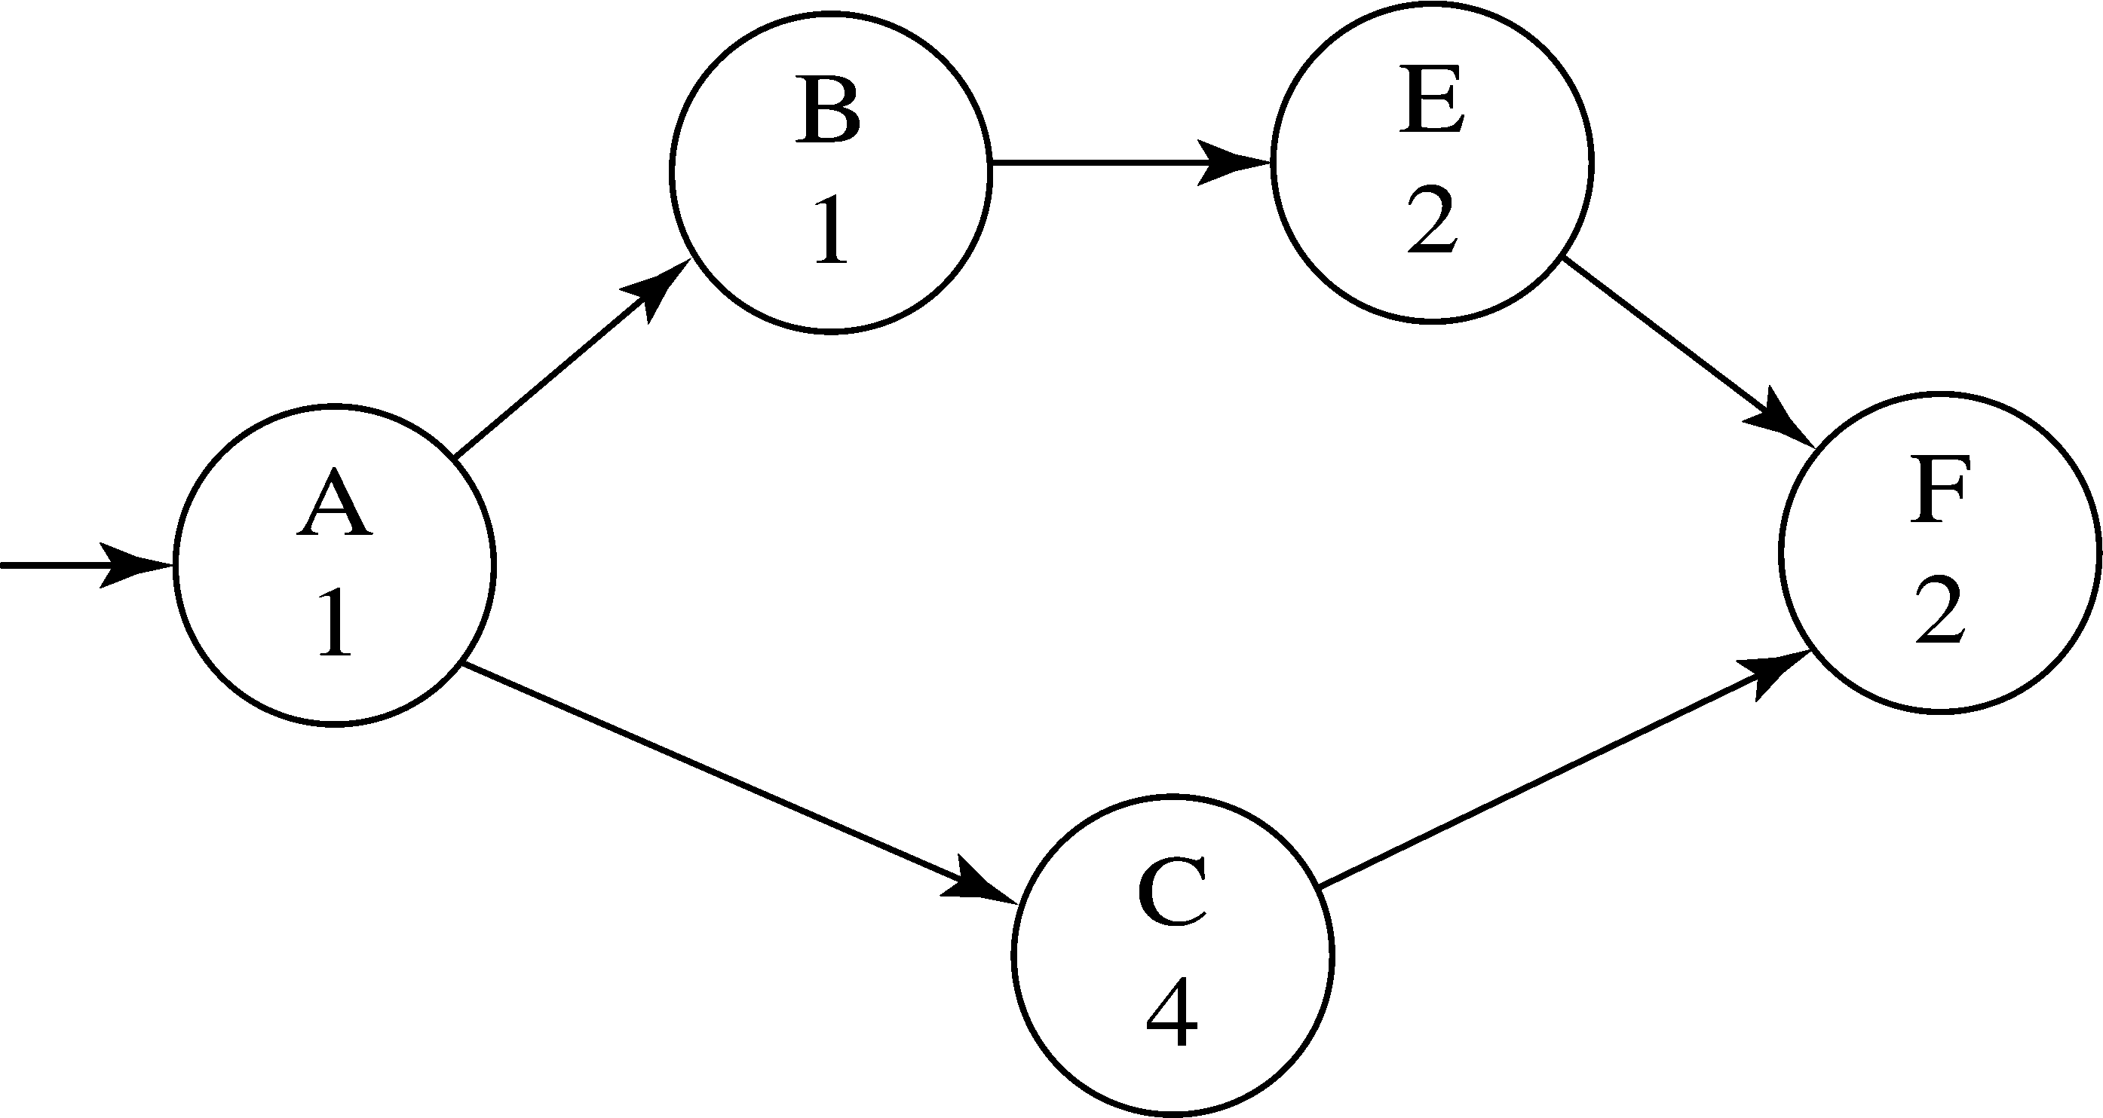

(b) The critical path, listing all critical activities in chronological order:
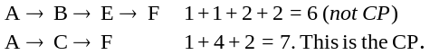
(c) The project duration (in weeks):
7 (This is the length of CP.)
(d) The slack (in weeks) associated with any and all non-critical paths through the project: Look at the paths that aren’t critical—only 1 here—so from above:
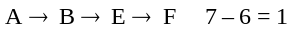 week slack.
3.16 Helps to modify the AON with the lowest costs to crash:
1. 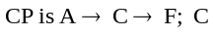 is cheapest to crash, so take it to
3 wks at $200 (and $200 < $250)
2. Now both paths through are critical. We would need to shorten A or F, or shorten C and either B/E. This is not worth it, so we would not bother to crash any further.

3.17

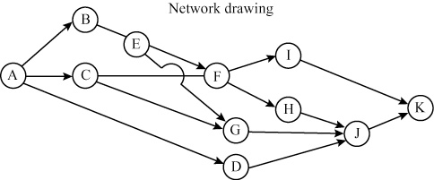

(a) Estimated (expected) time for C = [8 + (4 × 12) + 16]/6
= 72/6
= 12 weeks
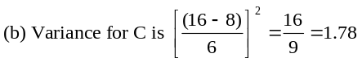
(c) Critical path is A–C–F–H–J–K
(d) Time on critical path = 7.67 + 12 + 9.67 + 2 + 6.67
+ 2.17 = 40.18 weeks (rounded)
(e) Variance on critical path = 1 + 1.78 + 5.44 + 0 + 1.78
+ 0.03 = 10.03
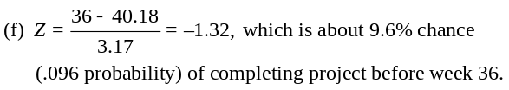
Note that based on possible rounding in part (d)—where time on critical path could be 40.3—the probability can be as low as 8.7%. So a student answer
between 8.7% and 9.6% is valid.
Summary table for problem 3.17 follows:
3.18
Activity | Activity  Time | Early  Start | Early  Finish | Late Start | Late  Finish | Slack | Standard  Deviation
A | 7.66 | 0 | 7.66 | 0.0 | 7.66 | 0 | 1
B | 9.66 | 7.66 | 17.33 | 8 | 17.66 | 0.33 | 3.66
C | 12 | 7.66 | 19.66 | 7.66 | 19.66 | 0 | 1.33
D | 6.33 | 7.66 | 14 | 25 | 31.33 | 17.33 | 1
E | 2 | 17.33 | 19.33 | 17.66 | 19.66 | 0.33 | 0.33
F | 9.66 | 19.66 | 29.33 | 19.66 | 29.33 | 0 | 2.33
G | 3 | 19.66 | 22.66 | 28.33 | 31.33 | 8.66 | 0.33
H | 2 | 29.33 | 31.33 | 29.33 | 31.33 | 0 | 0
I | 6 | 29.33 | 35.33 | 32 | 38 | 2.66 | 0
J | 6.66 | 31.33 | 38 | 31.33 | 38 | 0 | 1.33
K | 2.16 | 38 | 40.17 | 38 | 40.17 | 0 | 0.17

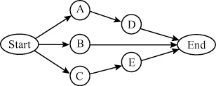
Critical path C–E at 12 days.
Activity | Daily Crash Costs | Maximum Crash
A | $100 | 1 day
B | 50 | 2 days
C | 100 | 1 day
D | 150 | 2 days
E | 200 | 3 days
To crash by 4 days, from 12 days to 8 days:
• Crash C by 1 day ($100) to 11 days total
• Now crash E by 1 day ($200) and A by 1 day ($100) to 10 days total.
• Now crash E by 2 days ($400) and D by 2 days ($300) to 8 days total.
• Total additional cost to crash 4 days = $1,100.
3.19 Crash costs per unit time are $600 for A, $900 for B, and $1,000 for C. (a) A offers the cheapest path to a single day reduction. (b) A cannot supply a second reduction, so the next best choice is B, which adds $900. (c) The total for both days is $1,500.
3.20 (a) Project completion time = 16 (Activities A–D–G)
Activity | Norm. Time–  Crash Time | Crash $–Normal $ | $/time
A | 1 | $600 | $600
B | 1 | 600 | 600
C | 0 | 0 | —
D | 4 | 300 | 75
E | 3 | 300 | 100
F | 1 | 1,200 | 1,200
G | 2 | 600 | 300
(b) Total cost = $12,300.
(c) Crash D 1 week at an additional cost of $75.

Figure for Problem 3.20
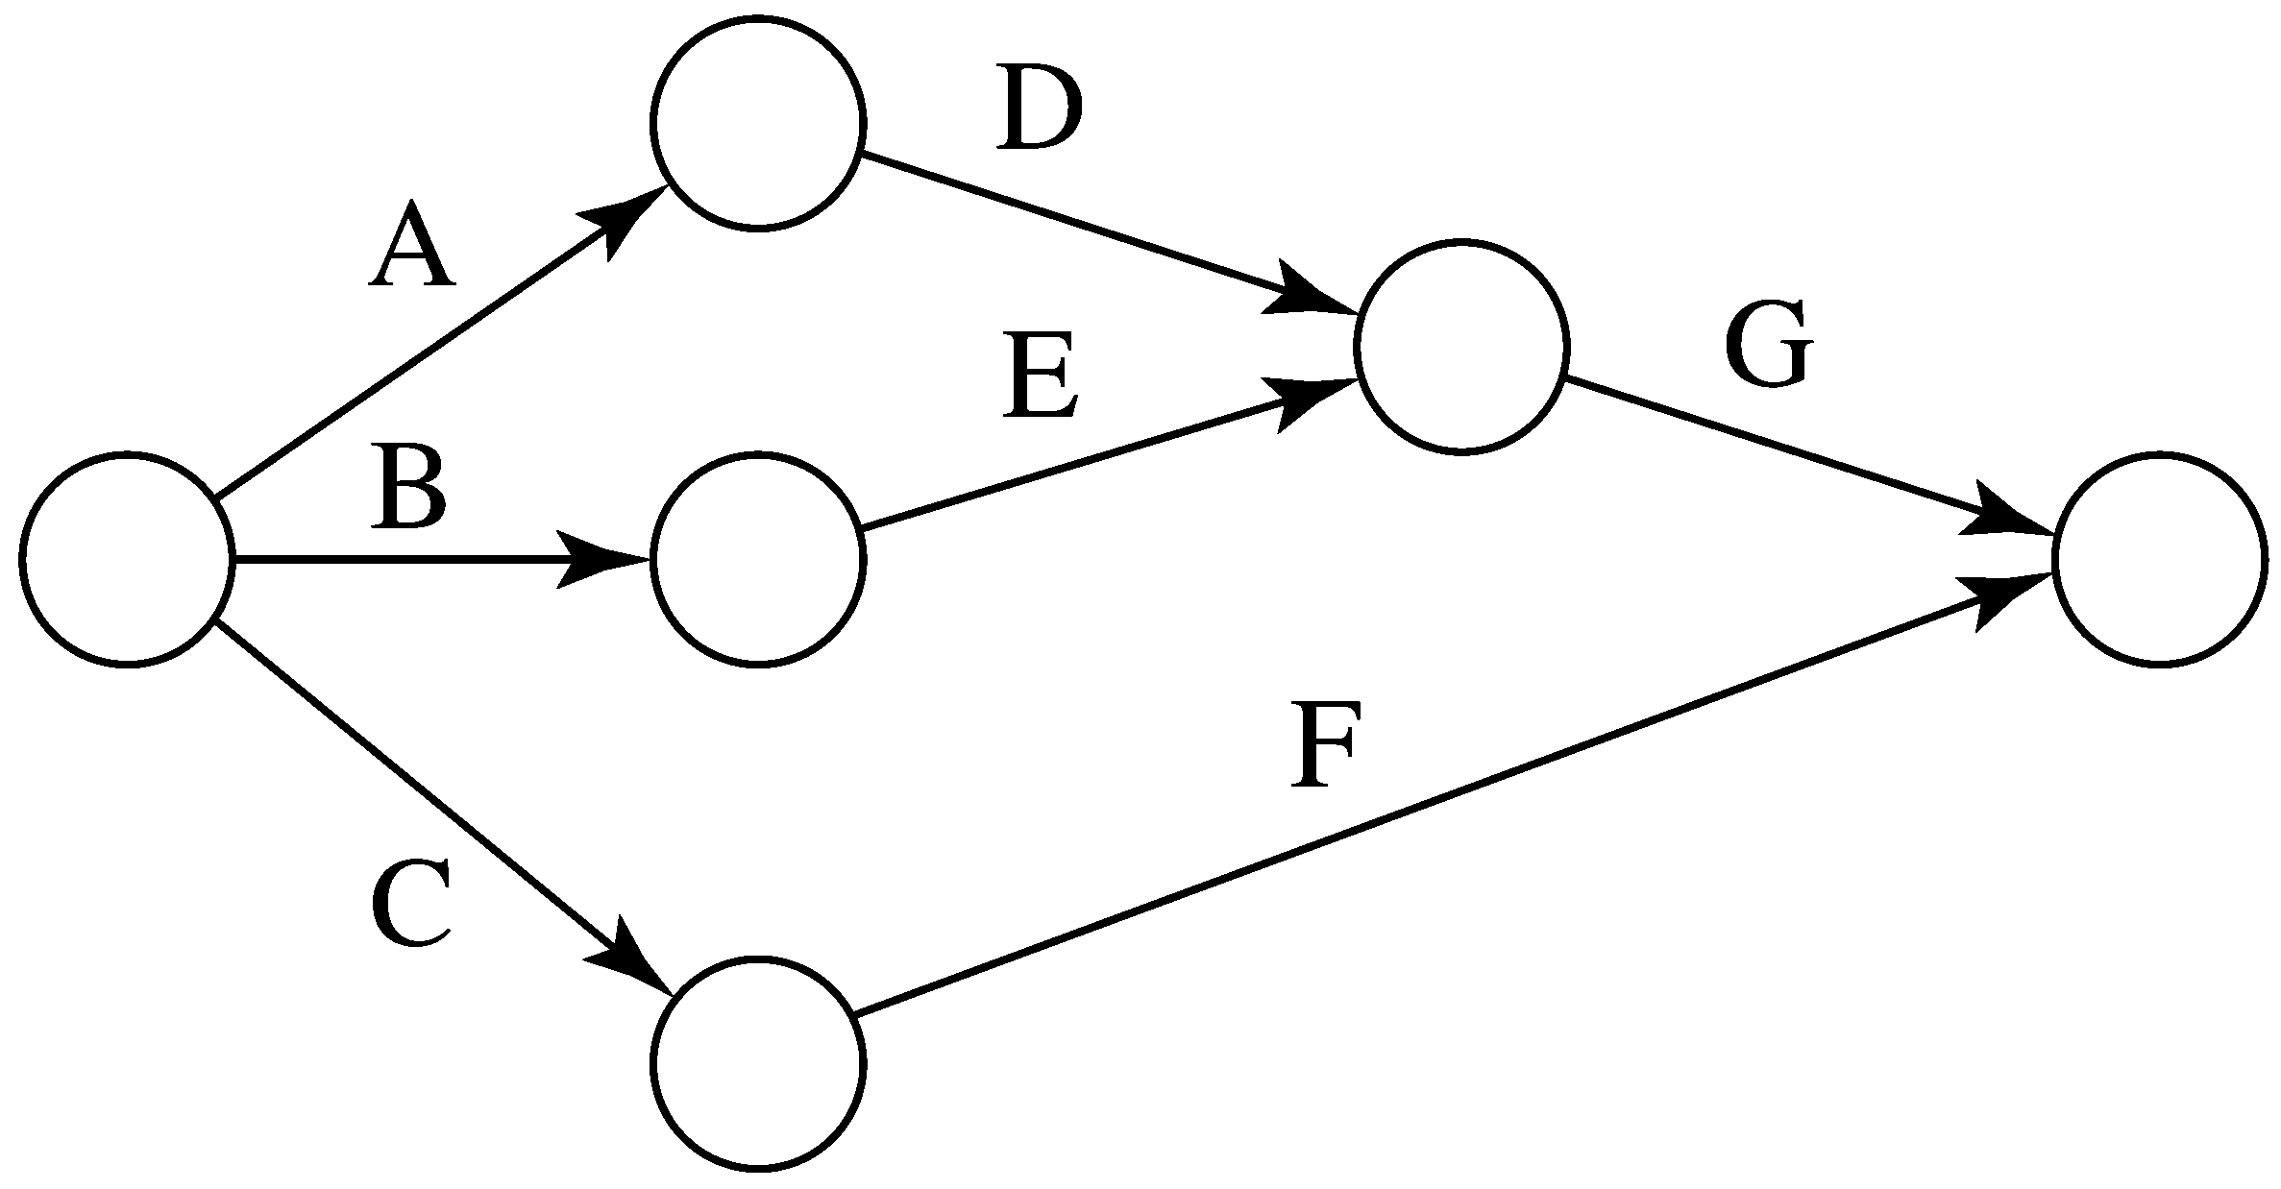
(d) | Activity | Crash |  | Cost
 | D | 4 |  | $300
 | G | 2 |  | 600
 | A | 1 |  | 600
 | E | 1 |  | 100
 |  | 7 weeks |  | $1,600

3.21 (a) | Activity | a | m | b | t_{e} | Variance
 | A | 9 | 10 | 11 | 10 | 0.11
 | B | 4 | 10 | 16 | 10 | 4
 | C | 9 | 10 | 11 | 10 | 0.11
 | D | 5 | 8 | 11 | 8 | 1
(b) Critical path is A–C with mean (te) completion time of 20 weeks. The other path is B–D, with mean
completion time of 18 weeks.
(c) Variance of A–C = (Variance of A) + (Variance of C)
= 0.11 + 0.11 = 0.22
Variance of B–D = (Variance of B) + (Variance of D)
= 4 + 1 = 5
(d) Probability A–C is finished in 22 weeks or less =
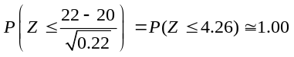
(e) Probability B–D is finished in 22 weeks or less =
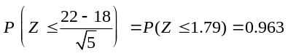
(f) The critical path has a relatively small variance and will almost certainly be finished in 22 weeks or less. Path B–D has a relatively high variance. Due to this, the probability B–D is finished in 22 weeks or less is only about 0.96. Since the project is not finished until all activities (and paths) are finished, the probability that the project will be finished in 22 weeks or less is not 1.00 but is approximately 0.96.
3.22 (a)
Activity | a | m | b | Expected Time | Variance
A | 4 | 6 | 7 | 5.83 | 0.25*
B | 1 | 2 | 3 | 2.00 | 0.11
C | 6 | 6 | 6 | 6.00 | 0.00*
D | 5 | 8 | 11 | 8.00 | 1.00
E | 1 | 9 | 18 | 9.17 | 8.03*
F | 2 | 3 | 6 | 3.33 | 0.44
G | 1 | 7 | 8 | 6.17 | 1.36
H | 4 | 4 | 6 | 4.33 | 0.11*
I | 1 | 6 | 8 | 5.50 | 1.36*
J | 2 | 5 | 7 | 4.83 | 0.69
K | 8 | 9 | 11 | 9.17 | 0.25*
L | 2 | 4 | 6 | 4.00 | 0.44
M | 1 | 2 | 3 | 2.00 | 0.11*
N | 6 | 8 | 10 | 8.00 | 0.44*

Activity | Time | ES | EF | LS | LF | Slack | Critical
A | 5.83 | 0.00 | 5.83 | 0.00 | 5.83 | 0.00 | Yes
B | 2.00 | 0.00 | 2.00 | 9.83 | 11.83 | 9.83 | No
C | 6.00 | 5.83 | 11.83 | 5.83 | 11.83 | 0.00 | Yes
D | 8.00 | 5.83 | 13.83 | 9.67 | 17.67 | 3.84 | No
E | 9.17 | 11.83 | 21.00 | 11.83 | 21.00 | 0.00 | Yes
F | 3.33 | 13.83 | 17.16 | 17.67 | 21.00 | 3.84 | No
G | 6.17 | 13.83 | 20.00 | 19.16 | 25.33 | 5.33 | No
H | 4.33 | 21.00 | 25.33 | 21.00 | 25.33 | 0.00 | Yes
I | 5.50 | 25.33 | 30.83 | 25.33 | 30.83 | 0.00 | Yes
J | 4.83 | 30.83 | 35.66 | 33.17 | 38.00 | 2.34 | No
K | 9.17 | 30.83 | 40.00 | 30.83 | 40.00 | 0.00 | Yes
L | 4.00 | 35.66 | 39.66 | 38.00 | 42.00 | 2.34 | No
M | 2.00 | 40.00 | 42.00 | 40.00 | 42.00 | 0.00 | Yes
N | 8.00 | 42.00 | 50.00 | 42.00 | 50.00 | 0.00 | Yes
The critical path is given by activities A, C, E, H, I, K, M, N. Completion time is 50 days.
(b) P(Completion in 53 days). Σ Variances on critical path
= 10.55 so, σcp = 3.25.
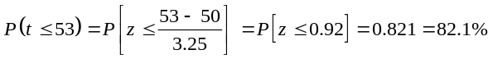
(c)
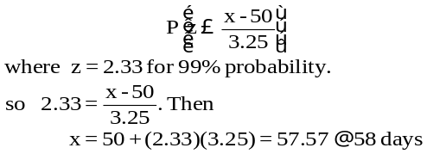
3.23 (a) This project management problem can be solved using
PERT. The results are below. As you can see, the total project completion time is about 32 weeks. The critical path consists of activities C, H, M, and O.
Project completion time = 32.05
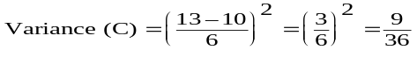
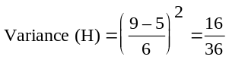
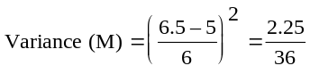
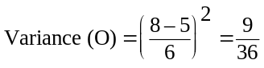
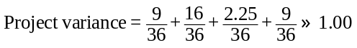
Project standard deviation = 1.00

Activity | Activity  Time | Early  Start | Early  Finish | Late  Start | Late  Finish | Slack
A | 2.16 | 0 | 2.16 | 10.13 | 12.3 | 10.13
B | 3.5 | 0 | 3.5 | 11.88 | 15.38 | 11.88
C | 11.83 | 0 | 11.83 | 0 | 11.83 | 0
D | 5.16 | 0 | 5.16 | 14.65 | 19.82 | 14.65
E | 3.83 | 0 | 3.83 | 15.98 | 19.82 | 15.98
F | 7 | 2.17 | 9.16 | 12.3 | 19.3 | 10.13
G | 3.92 | 3.5 | 7.42 | 15.38 | 19.3 | 11.88
H | 7.47 | 11.83 | 19.3 | 11.83 | 19.3 | 0
I | 10.32 | 11.83 | 22.15 | 14.9 | 25.22 | 3.06
J | 3.83 | 11.83 | 15.66 | 19.98 | 23.82 | 8.15
K | 4 | 5.16 | 9.16 | 19.82 | 23.82 | 14.65
L | 4 | 3.83 | 7.83 | 19.82 | 23.82 | 15.98
M | 5.92 | 19.3 | 25.22 | 19.3 | 25.22 | 0
N | 1.23 | 15.66 | 16.9 | 23.82 | 22.05 | 8.15
O | 6.83 | 25.22 | 32.05 | 25.22 | 32.05 | 0
P | 7 | 16.9 | 23.9 | 25.05 | 32.05 | 8.15
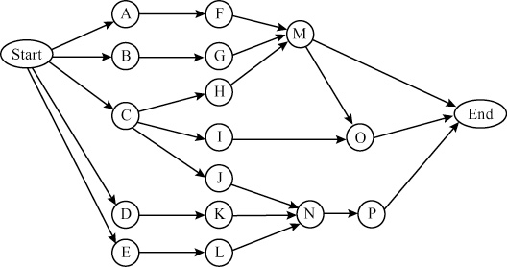
(b) As can be seen in the following analysis, the changes do not have any impact on the critical path or the total project completion time. A summary of the analysis is below.
Project completion time = 32.05
Project standard deviation = 1.00
Activity | Activity  Time | Early  Start | Early  Finish | Late  Start | Late  Finish | Slack
A | 2.16 | 0 | 2.16 | 10.13 | 12.3 | 10.13
B | 3.5 | 0 | 3.5 | 11.88 | 15.38 | 11.88
C | 11.83 | 0 | 11.83 | 0 | 11.83 | 0
D | 5.16 | 0 | 5.16 | 14.65 | 19.82 | 14.65
E | 3.83 | 0 | 3.83 | 15.98 | 19.82 | 15.98
F | 7 | 2.16 | 9.16 | 12.3 | 19.3 | 10.13
G | 3.92 | 3.5 | 7.42 | 15.38 | 19.3 | 11.88
H | 7.46 | 11.83 | 19.3 | 11.83 | 19.3 | 0
I | 0 | 11.83 | 11.83 | 25.22 | 25.22 | 13.38
J | 0 | 11.83 | 11.83 | 23.82 | 23.82 | 11.98
K | 4 | 5.16 | 9.16 | 19.82 | 23.82 | 14.65
L | 4 | 3.83 | 7.83 | 19.82 | 23.82 | 15.98
M | 5.92 | 19.3 | 25.22 | 19.3 | 25.22 | 0
N | 1.23 | 11.83 | 13.06 | 23.82 | 22.05 | 11.98
O | 6.83 | 25.22 | 32.05 | 25.22 | 32.05 | 0
P | 7 | 13.06 | 20.06 | 25.05 | 32.05 | 11.98
3.24 (a) Probability of completion is 17 months or less:
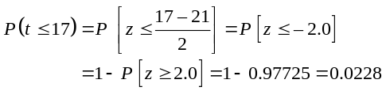
(b) Probability of completion in 20 months or less:
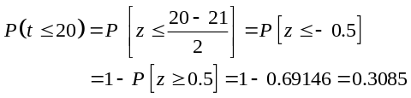
(c) Probability of completion in 23 months or less:
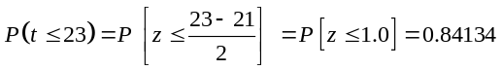
(d) Probability of completion in 25 months or less:
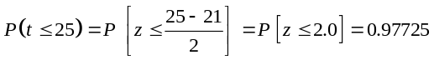
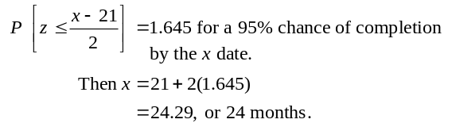 (e)
3.25 (a)
Project completion time = 14 weeks
Task | Time | ES | EF | LS | LF | Slack
A | 3 | 0 | 3 | 0 | 3 | 0
B | 2 | 0 | 2 | 2 | 4 | 2
C | 1 | 0 | 1 | 11 | 12 | 11
D | 7 | 3 | 10 | 3 | 10 | 0
E | 6 | 2 | 8 | 4 | 10 | 2
F | 2 | 1 | 3 | 12 | 14 | 11
G | 4 | 10 | 14 | 10 | 14 | 0
(b) To crash to 10 weeks, we follow 2 steps:
- Step 1: crash D by 2 weeks ($150)
- Crash D and E by 2 weeks each ($100 + $150)
Total crash cost = $400 additional
(c) Using POM for Windows software, minimum project
completion time = 7. Additional crashing cost = $1,550.
 | Normal  Time | Crash  Time | Normal  Cost | Crash  Cost | Crash  Cost/Pd | Crash  By | Crashing  Cost
A | 3 | 2 | 1,000 | 1,600 | 600 | 1 | 600
B | 2 | 1 | 2,000 | 2,700 | 700 | 0 | 0
C | 1 | 1 | 300 | 300 | 0 | 0 | 0
D | 7 | 3 | 1,300 | 1,600 | 75 | 4 | 300
E | 6 | 3 | 850 | 1,000 | 50 | 3 | 150
F | 2 | 1 | 4,000 | 5,000 | 1,000 | 0 | 0
G | 4 | 2 | 1,500 | 2,000 | 250 | 2 | 500

3.26 (a)
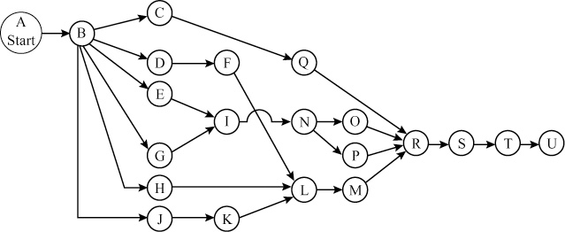
3.26 (b)
Task | Time | ES | EF | LS | LF | Slack
A | 0.0* | 0.0 | 0.0 | 0.0 | 0.0 | 0.0
B | 8.0 | 0.0 | 8.0 | 0.0 | 8.0 | 0.0
C | 0.1 | 8.0 | 8.1 | 10.4 | 10.5 | 2.4
D | 1.0 | 8.0 | 9.0 | 12.0 | 13.0 | 4.0
E | 1.0 | 8.0 | 9.0 | 10.0 | 11.0 | 2.0
F | 1.0 | 9.0 | 10.0 | 13.0 | 14.0 | 4.0
G | 2.0 | 8.0 | 10.0 | 9.0 | 11.0 | 1.0
H | 3.0 | 8.0 | 11.0 | 11.0 | 14.0 | 3.0
I | 1.0 | 10.0 | 11.0 | 11.0 | 12.0 | 1.0
J | 4.0 | 8.0 | 12.0 | 8.0 | 12.0 | 0.0
K | 2.0 | 12.0 | 14.0 | 12.0 | 14.0 | 0.0
L | 1.0 | 14.0 | 15.0 | 14.0 | 15.0 | 0.0
M | 0.5 | 15.0 | 15.5 | 15.0 | 15.5 | 0.0
N | 2.0 | 11.0 | 13.0 | 12.0 | 14.0 | 1.0
O | 1.0 | 13.0 | 14.0 | 14.5 | 15.5 | 1.5
P | 1.5 | 13.0 | 14.5 | 14.0 | 15.5 | 1.0
Q | 5.0 | 8.1 | 13.1 | 10.5 | 15.5 | 2.4
R | 1.0 | 15.5 | 16.5 | 15.5 | 16.5 | 0.0
S | 0.5 | 16.5 | 17.0 | 16.5 | 17.0 | 0.0
T | 1.0 | 17.0 | 18.0 | 17.0 | 18.0 | 0.0
U | 0.0* | 18.0 | 18.0 | 18.0 | 18.0 | 0.0
*Note: Start (A) and Finish (U) are assigned times of zero.
Critical path is A–B–J–K–L–M–R–S–T–U, for 18 days.
(c) (i) no, transmissions and drivetrains are not on the critical path.
(ii) no, halving engine building time will reduce the critical path by only one day.
(iii) no, it is not on the critical path.
(d) Reallocating workers not involved with critical path activities to activities along the critical path will reduce the critical path length.
Additional Homework Problems*
Problems 3.27 to 3.33 appear on our Internet home page, at www.pearsonglobaleditions.com/myomlab
3.27 (a)
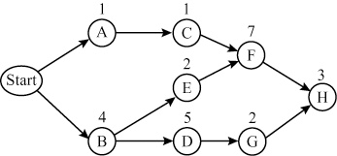
(b) Critical path is B–E–F–H.
(c) Time = 16 weeks
3.28 (a) Expected times for individual activities (using (a + 4m + b)/6)). A = 5, B = 6, C = 7, D = 6, E = 3. Expected project completion time = 15 (Activities A–C–E).
(b) Variance for individual activities (using [(b – a)/6]2).
A = 1; B = 1; C = 1; D = 4; E = 0. Project
variance = Σ variances on critical path = 1 + 1 + 0 = 2.
* Note to instructor: To broaden the selection of homework problems, these seven problems are also available to you and your students.

3.29 (a)
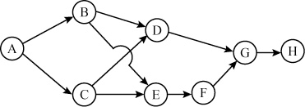
(b)
Activity | Time | ES | EF | LS | LF | Slack | σ | σ2
A | 7 | 0 | 7 | 0 | 7 | 0 | 2 | 4*
B | 3 | 7 | 10 | 13 | 16 | 6 | 1 | 1*
C | 9 | 7 | 16 | 7 | 16 | 0 | 3 | 9*
D | 4 | 16 | 20 | 25 | 29 | 9 | 1 | 1*
E | 5 | 16 | 21 | 16 | 21 | 0 | 1 | 1*
F | 8 | 21 | 29 | 21 | 29 | 0 | 2 | 4*
G | 8 | 29 | 37 | 29 | 37 | 0 | 1 | 1*
H | 6 | 37 | 43 | 37 | 43 | 0 | 2 | 4*
*Activities on the critical path: A, C, E, F, G, H. Project Completion time = 43.
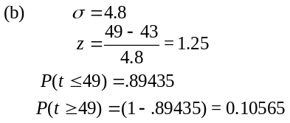
3.30 AON Network
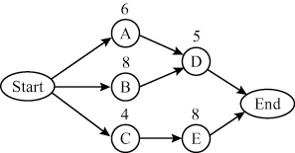
Critical path is: B − D, at 13 days
Activity | Daily Crash Costs | Maximum Crash (days)
A | $100 | 1 day
B | 50 | 2 days
C | 100 | 1 day
D | 150 | 2 days
E | 200 | 3 days
To crash by 4 days, from 13 days to 9 days,
- Crash B by 1 day ($50) to reach 12 days
- Crash B by a second day ($50) and C by 1 day ($100) to reach 11 days.
- Crash D by 2 days ($300) and E by 2 days ($400) to reach 9 days total.
- Total cost to crash 4 days = $900
3.31 (a)
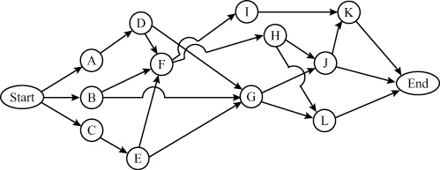
(b) Expected times and variances:
Activity | a | m | b | Expected Time | Variance
A | 8 | 10 | 12 | 10.0 | 0.44
B | 6 | 7 | 9 | 7.2 | 0.25
C | 3 | 3 | 4 | 3.2 | 0.03
D | 10 | 20 | 30 | 20.0 | 11.11
E | 6 | 7 | 8 | 7.0 | 0.11
F | 9 | 10 | 11 | 10.0 | 0.11
G | 6 | 7 | 10 | 7.3 | 0.44
H | 14 | 15 | 16 | 15.0 | 0.11
I | 10 | 11 | 13 | 11.2 | 0.25
J | 6 | 7 | 8 | 7.0 | 0.11
K | 4 | 7 | 8 | 6.7 | 0.44
L | 1 | 2 | 4 | 2.2 | 0.25
(c) ES, EF, LS, LF, and slack times:
Activity | Time | ES | EF | LS | LF | Slack | Critical
A | 10.0 | 0.0 | 10.0 | 0.0 | 10.0 | 0.0 | Yes
B | 7.2 | 0.0 | 7.2 | 22.8 | 30.0 | 22.8 | No
C | 3.2 | 0.0 | 3.2 | 19.8 | 23.0 | 19.8 | No
D | 20.0 | 10.0 | 30.0 | 10.0 | 30.0 | 0.0 | Yes
E | 7.0 | 3.2 | 10.2 | 23.0 | 30.0 | 19.8 | No
F | 10.0 | 30.0 | 40.0 | 30.0 | 40.0 | 0.0 | Yes
G | 7.3 | 30.0 | 37.3 | 47.7 | 55.0 | 17.7 | No
H | 15.0 | 40.0 | 55.0 | 40.0 | 55.0 | 0.0 | Yes
I | 11.2 | 40.0 | 51.2 | 50.8 | 62.0 | 10.8 | No
J | 7.0 | 55.0 | 62.0 | 55.0 | 62.0 | 0.0 | Yes
K | 6.7 | 62.0 | 68.7 | 62.0 | 68.7 | 0.0 | Yes
L | 2.2 | 55.0 | 57.2 | 66.5 | 68.7 | 11.5 | No
(d) The critical path is given by the activities:
A, D, F, H, J, K
Expected project completion time is 68.7 days.
(e) Probability of completion in 70 days or less:
Project variance = sum of variances of activities
on critical path
= 0.44 + 11.11 + 0.11 + 0.11 +
0.44 = 12.32
Standard deviation = 3.51
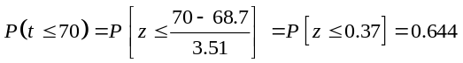
(f) Probability of completion in 80 days or less:
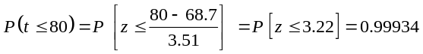
(g) Probability of completion in 90 days or less:
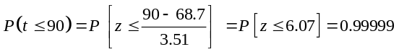
3.32 The overall purpose of Problem 3.32 is to have students use a network to solve a problem that almost all students face. The first step is for students to list all courses that they must take,
including possible electives, to get a degree from their particular college or university. For every course, students should list all the immediate predecessors. Then students are asked to attempt to
develop a network diagram that shows these courses and their immediate predecessors or prerequisite courses.
This problem can also point out some of the limitations of the use of project management. As students try to solve this problem they may run into several difficulties. First, it is difficult to incorporate a minimum or maximum number of courses that a stu-dent can take during a given semester. In addition, it is difficult to schedule elective courses. Some elective courses have prerequisites,
while others may not. Even so, some of the overall approaches of network analysis can be helpful in terms of laying out the courses that are required and their prerequisites.
Students can also be asked to think about other techniques that can be used in solving this problem. One of the most appropri-
ate approaches would be to use linear programming to incorporate many of the constraints, such as minimum and maximum number of credit hours per semester, that are difficult or impossible to incorporate in a project network.
3.33 The Construction Company problem involves 23 separate activities. These activities, their immediate predecessors, and time estimates were given in the problem. One of the most difficult
aspects of this problem is to take the data in the table given in the problem and to construct a network diagram. This network diagram
is necessary in order to determine beginning and ending node
numbers that can be used in the computer program to solve this particular problem. The network diagram for this problem is as follows:

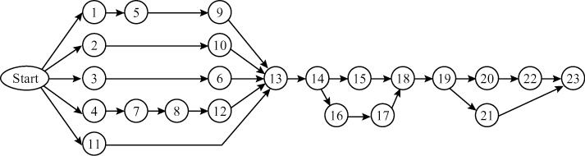
Once this diagram has been developed, activity numbers, starting and finishing node numbers, and the three time estimates for each activity can be entered into the computer program. The computer program calculates the expected time and variance
estimates for each activity, the expected project length, variance, and data for all activities. Like the other network problems, these data include the earliest start time, earliest finish time, latest start time, latest time, and slack for all activities. The data are as follows:

Table for Problem 3.33
 | Times
Activity | Opt | Most | Pess | E(t) | σ | ES | EF | LS | LF | Slack
1 | 1.0 | 4.00 | 5.00 | 3.67 | 0.67 | 0.00 | 3.67 | 9.00 | 12.67 | 9.00
2 | 2.0 | 3.00 | 4.00 | 3.00 | 0.33 | 0.00 | 3.00 | 16.50 | 19.50 | 16.50
3 | 3.0 | 4.00 | 5.00 | 4.00 | 0.33 | 0.00 | 4.00 | 14.50 | 18.50 | 14.50
4 | 7.0 | 8.00 | 9.00 | 8.00 | 0.33 | 0.00 | 8.00 | 3.50 | 11.50 | 3.50
5 | 4.0 | 4.00 | 5.00 | 4.17 | 0.17 | 3.67 | 7.83 | 12.67 | 16.83 | 9.00
6 | 1.0 | 2.00 | 4.00 | 2.17 | 0.50 | 4.00 | 6.17 | 18.50 | 20.67 | 14.50
7 | 4.0 | 5.00 | 6.00 | 5.00 | 0.33 | 8.00 | 13.00 | 11.50 | 16.50 | 3.50
8 | 1.0 | 2.00 | 4.00 | 2.17 | 0.50 | 13.00 | 15.17 | 16.50 | 18.67 | 3.50
9 | 3.0 | 4.00 | 4.00 | 3.83 | 0.17 | 7.83 | 11.67 | 16.83 | 20.67 | 9.00
10 | 1.0 | 1.00 | 2.00 | 1.17 | 0.17 | 3.00 | 4.17 | 19.50 | 20.67 | 16.5
11 | 18.0 | 20.00 | 26.00 | 20.67 | 1.33 | 0.00 | 20.67 | 0.00 | 20.67 | 0.00
12 | 1.0 | 2.00 | 3.00 | 2.00 | 0.33 | 15.17 | 17.17 | 18.67 | 20.67 | 3.50
13 | 1.0 | 1.00 | 2.00 | 1.17 | 0.17 | 20.67 | 21.83 | 20.67 | 21.83 | 0.00
14 | 0.1 | 0.14 | 0.16 | 0.14 | 1.00 | 21.83 | 21.97 | 21.83 | 21.97 | 0.00
15 | 0.2 | 0.30 | 0.40 | 0.30 | 0.03 | 21.97 | 22.27 | 24.84 | 25.14 | 2.87
16 | 1.0 | 1.00 | 2.00 | 1.17 | 0.17 | 21.97 | 23.14 | 21.97 | 23.14 | 0.00
17 | 1.0 | 2.00 | 3.00 | 2.00 | 0.33 | 23.14 | 25.14 | 23.14 | 25.14 | 0.00
18 | 3.0 | 5.00 | 7.00 | 5.00 | 0.67 | 25.14 | 30.14 | 25.14 | 30.14 | 0.00
19 | 0.1 | 0.10 | 0.20 | 0.12 | 0.02 | 30.14 | 30.25 | 30.14 | 30.25 | 0.00
20 | 0.1 | 0.14 | 0.16 | 0.14 | 0.00 | 30.25 | 30.39 | 33.33 | 33.47 | 3.08
21 | 2.0 | 3.00 | 6.00 | 3.33 | 0.67 | 30.25 | 33.59 | 30.25 | 33.59 | 0.00
22 | 0.1 | 0.10 | 0.20 | 0.12 | 0.02 | 30.39 | 30.50 | 33.47 | 33.58 | 3.08
23 | 0.0 | 0.20 | 0.20 | 0.17 | 0.03 | 33.59 | 33.75 | 33.59 | 33.75 | 0.00
As you can see, the expected project length is about 34 weeks. The activities along the critical path are activities
11, 13, 14, 16, 17, 18, 19, 21, and 23.

Case Study
SOUTHWESTERN UNIVERSITY: A
1.
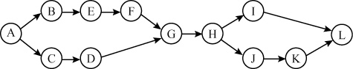

Activity Mean | S.D. | Variance
t_{A} = 30 | 3.33* | 11.11
t_{B} = 60 | 10.00 | 100.00
t_{C} = 65 | 8.33* | 69.39
t_{D} = 55 | 11.66* | 136.10
t_{E} = 30 | 1.67 | 2.78
t_{F} = 0 | 0.10 | 0.00
t_{G} = 30 | 1.67* | 2.78
t_{H} = 20 | 3.33* | 11.11
t_{I} = 30 | 6.67* | 44.44
t_{J} = 10 | 0.67 | 0.44
t_{K} = 0 | 0.10 | 0.00
t_{L} = 30 | 6.67* | 44.44
*Critical path
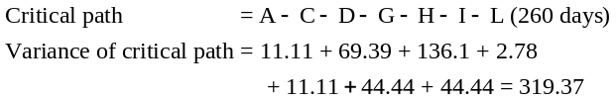Standard deviation of critical path = 17.87 days
2. P (Completion < 270 days) = P(t ≤ 270)
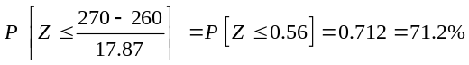
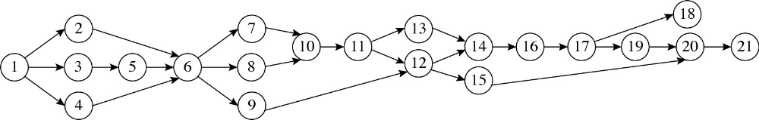3. Crash to 250 days and to 240 days
Activity | Normal  Time (days) | Crash  Time (days) | Crash  Cost/Day
A | 30 | 20 | $1,500
B | 60 | 20 | $3,500
C | 65 | 50 | $4,000
D | 55 | 30 | $1,900
E | 30 | 25 | $9,500
F | 0* | 0 | $0
G | 30 | 25 | $2,500
H | 20 | 10 | $2,000
I | 30 | 20 | $2,000
J | 10 | 8 | $6,000
K | 0* | 0 | $0
L | 30 | 20 | $4,500
*Rounded to zero from 0.1
To crash to 250 days (from the current 260 days), select A at $1,500/day × 10 days = $15,000.
To crash to 240 days now (from the current 250 days), select D at $1,900/day × 10 days = $19,000.
Total cost to crash to 240 days = $34,000 additional.
Video Case Studies
PROJECT MANAGEMENT AT ARNOLD PALMER HOSPITAL
1
The Arnold Palmer Hospital video for this case (8 minutes) is available from Pearson Education. Also note that the Global Company Profile in Chapter 6 highlights this hospital.
1. Construction project network:

2. The critical path is Activities 1–3–5–6–8–10–11–12–14–16–17–19–20–21. The project length is 47 months—about four years from start to finish.
3. Building a hospital is much more complex than an office building for several reasons. In this case, hundreds of “users” of the new building had extensive input. Second, the design of the new layout (circular, pod design) is somewhat radical compared to traditional “linear” hospitals. Third, the hospital was built with future expansion in mind. Fourth, the guiding principles impacted on design/construction. Fifth, hospitals, by their very nature, are more complex from a safety, health hazard, security, quiet, serenity perspective than an office building.
4. Since there were 13 months of planning prior to the proposal/ review stage (listed as Activity 1) and the project then took
47 months (for a total of 60 months), 22% of the time was spent in planning.
Construction itself started with activity 14 (19.75 months); there were 13 + 19.75 months of work (= 32.75 months) out of
60 months, or 55% of the time was spent prior to building beginning.
These figures reflect the importance of preplanning placed on the project. Rather than having to redo walls or rooms, mockups and detailed planning meetings saved time on the back end and resulted in a building that met the needs of patients and staff alike. It always pays to spend extra time on the front end of a large project.
MANAGING HARD ROCK’S ROCKFEST
2
There is a short (9-minute) video available from Pearson Education and filmed specifically for this text that supplements this case.
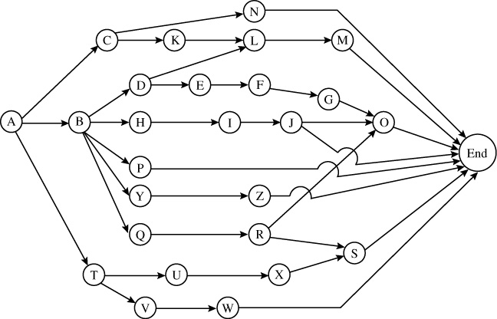
Network diagram
Hard Rock’s ES, EF, LS, LF, and Slack
 | Activity  time | Early  Start | Early  Finish | Late Start | Late  Finish | Slack
A | 7 | 0 | 7 | 0 | 7 | 0
B | 3 | 7 | 10 | 7 | 10 | 0
C | 3 | 7 | 10 | 18 | 21 | 11
D | 5 | 10 | 15 | 10 | 15 | 0
E | 6 | 15 | 21 | 15 | 21 | 0
F | 4 | 21 | 25 | 21 | 25 | 0
G | 2 | 25 | 27 | 25 | 27 | 0
H | 4 | 10 | 14 | 16 | 20 | 6
I | 4 | 14 | 18 | 20 | 24 | 6
J | 10 | 18 | 28 | 24 | 34 | 6
K | 2 | 10 | 12 | 21 | 23 | 11
L | 3 | 15 | 18 | 23 | 26 | 8
M | 8 | 18 | 26 | 26 | 34 | 8
N | 6 | 10 | 16 | 28 | 34 | 18
O | 7 | 27 | 34 | 27 | 34 | 0
P | 20 | 10 | 30 | 14 | 34 | 4
Q | 4 | 10 | 14 | 19 | 23 | 9
R | 4 | 14 | 18 | 23 | 27 | 9
S | 3 | 25 | 28 | 31 | 34 | 6
T | 4 | 7 | 11 | 13 | 17 | 6
U | 6 | 11 | 17 | 17 | 23 | 6
V | 7 | 11 | 18 | 23 | 30 | 12
W | 4 | 18 | 22 | 30 | 34 | 12
X | 8 | 17 | 25 | 23 | 31 | 6
Y | 6 | 10 | 16 | 22 | 28 | 12
Z | 6 | 16 | 22 | 28 | 34 | 12
1. The critical path is A–B–D–E–F–G–O, with a timeline of
34 weeks.
2. Activities C, K, L, M, N, Q, R, V, W, Y, and Z have slacks of 8 or more weeks
3. Major challenges a project manager faces in a project like Rockfest: (1) keeping in touch with each person responsible for major activities, (2) last-minute surprises, (3) cost overruns,
(4) too many fans trying to enter the venue, (5) resignations of
one of the key managers or promoters, and many others.

4. Work breakdown structure, with example of Level 1, 2, 3, 4 tasks
1.0 Rockfest event, with site selected (A) [Level 1]
1.1 Select local promoter (B) [Level 2]
1.11 Web site (D) [Level 3]
1.12 TV deal (E)
1.13 Hire director (F)
1.131 Camera placement (G) [Level 4]
1.14 Headline entertainers (H)
1.141 Support entertainers (I)
1.142 Travel for talent (J)
1.143 Passes/stage credentials (O)
1.15 Staff travel (P)
1.16 Merchandise deals (Y)
1.161 Online sales of merchandise (Z)
1.17 Hire sponsor coordinator (Q)
1.171 Finalize sponsors (R)
1.172 Signage for sponsors (S)
1.2 Hire production manager (C)
1.21 Sound/staging (N)
1.22 Venue capacity (K)
1.221 TicketMaster contract (L)
1.222 Onsite ticketing (M)
1.3 Hire operations manager (T)
1.31 Site plan (U)
1.311 Power, etc. (X)
1.32 Security director (V)
1.321 Set police/fire plan (W)
Answers may vary somewhat at the Level 3 and Level 4.
Level 2 activities should be activities B, C, and T.
Additional Case Study*
SHALE OIL COMPANY
1. Determine the expected shutdown time and the probability the shutdown will be completed one week earlier.
2. What are the probabilities that Shale finishes the maintenance project one day, two days, three days, four days, five days, or six days earlier?
From the precedence data supplied in the problem, we can develop the following AON network.
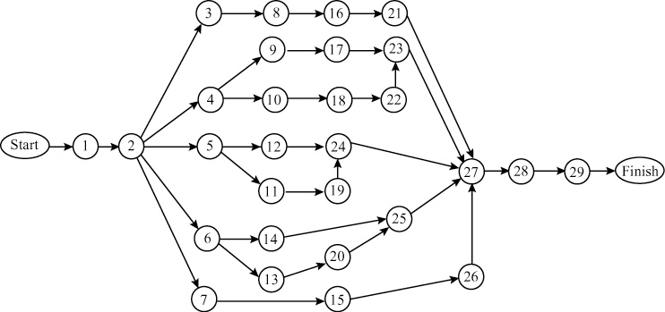

* This case study is found on our Companion Web sites, at
www.pearsonglobaleditions.com/heizer, and at www.pearsonglobaleditions.com/myomlab

The following table indicates the expected times, variances, and slacks needed to complete the rest of the case:
Activity | Opt | Most  Likely | Pess | E(t) | σ | ES | EF | LS | LF | Slack
1 | 1.0 | 2.0 | 2.5 | 1.92 | 0.25 | 0.00 | 1.92 | 0.00 | 1.92 | 0.000
2 | 1.5 | 2.0 | 2.5 | 2.00 | 0.17 | 1.92 | 3.92 | 1.92 | 3.92 | 0.000
3 | 2.0 | 3.0 | 4.0 | 3.00 | 0.33 | 3.92 | 6.92 | 3.92 | 6.92 | 0.000
4 | 1.0 | 2.0 | 3.0 | 2.00 | 0.33 | 3.92 | 5.92 | 22.50 | 24.50 | 18.580
5 | 1.0 | 2.0 | 4.0 | 2.17 | 0.50 | 3.92 | 6.08 | 10.25 | 12.42 | 6.333
6 | 2.0 | 2.5 | 3.0 | 2.50 | 0.17 | 3.92 | 6.42 | 13.42 | 15.92 | 9.500
7 | 2.0 | 4.0 | 5.0 | 3.83 | 0.50 | 3.92 | 7.75 | 29.58 | 33.42 | 25.670
8 | 1.0 | 2.0 | 3.0 | 2.00 | 0.33 | 6.92 | 8.92 | 6.92 | 8.92 | 0.000
9 | 1.0 | 1.5 | 2.0 | 1.50 | 0.17 | 5.92 | 7.42 | 26.67 | 28.17 | 20.750
10 | 1.0 | 1.5 | 2.0 | 1.50 | 0.17 | 5.92 | 7.42 | 24.50 | 26.00 | 18.580
11 | 2.0 | 2.5 | 3.0 | 2.50 | 0.17 | 6.08 | 8.58 | 19.92 | 22.42 | 13.830
12 | 15.0 | 20.0 | 30.0 | 20.83 | 2.50 | 6.08 | 26.92 | 12.42 | 33.25 | 6.330
13 | 1.0 | 1.5 | 2.0 | 1.50 | 0.17 | 6.42 | 7.92 | 15.92 | 17.42 | 9.500
14 | 3.0 | 5.0 | 8.0 | 5.17 | 0.83 | 6.42 | 11.58 | 28.08 | 33.25 | 21.670
15 | 3.0 | 8.0 | 15.0 | 8.33 | 2.00 | 7.75 | 16.08 | 33.42 | 41.75 | 25.670
16 | 14.0 | 21.0 | 28.0 | 21.00 | 2.33 | 8.92 | 29.92 | 8.92 | 29.92 | 0.000
17 | 1.0 | 5.0 | 10.0 | 5.17 | 1.50 | 7.42 | 12.58 | 28.17 | 33.33 | 20.750
18 | 2.0 | 5.0 | 10.0 | 5.33 | 1.33 | 7.42 | 12.75 | 26.00 | 31.33 | 18.580
19 | 5.0 | 10.0 | 20.0 | 10.83 | 2.50 | 8.58 | 19.42 | 22.42 | 33.25 | 13.830
20 | 10.0 | 15.0 | 25.0 | 15.83 | 2.50 | 7.92 | 23.75 | 17.42 | 33.25 | 9.500
21 | 4.0 | 5.0 | 8.0 | 5.33 | 0.67 | 29.92 | 35.25 | 29.92 | 35.25 | 0.000
22 | 1.0 | 2.0 | 3.0 | 2.00 | 0.33 | 12.75 | 14.75 | 31.33 | 33.33 | 18.580
23 | 1.0 | 2.0 | 2.5 | 1.92 | 0.25 | 14.75 | 16.67 | 33.33 | 35.25 | 18.580
24 | 1.0 | 2.0 | 3.0 | 2.00 | 0.33 | 26.92 | 28.92 | 33.25 | 35.25 | 6.330
25 | 1.0 | 2.0 | 3.0 | 2.00 | 0.33 | 23.75 | 25.75 | 33.25 | 35.25 | 9.500
26 | 2.0 | 4.0 | 6.0 | 4.00 | 0.67 | 16.08 | 20.08 | 41.75 | 45.75 | 25.670
27 | 1.5 | 2.0 | 2.5 | 2.00 | 0.17 | 35.25 | 37.25 | 35.25 | 37.25 | 0.000
28 | 1.0 | 3.0 | 5.0 | 3.00 | 0.67 | 37.25 | 40.25 | 37.25 | 40.25 | 0.000
29 | 3.0 | 5.0 | 10.0 | 5.50 | 1.17 | 40.25 | 45.75 | 40.25 | 45.75 | 0.000
From the table, we can see that the expected shutdown time is 45.75, or 46 days. There are nine activities on the critical path.
Activity | σ | σ²
1 | 0.25 | 0.0625
2 | 0.17 | 0.0289
3 | 0.33 | 0.1089
8 | 0.33 | 0.1089
16 | 2.33 | 5.4289
21 | 0.67 | 0.4489
27 | 0.17 | 0.0289
28 | 0.67 | 0.4489
29 | 1.17 | 1.3689
Variance for critical path: |  | 8.0337
Therefore, 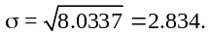 As an approximation, we can use the customary equation for the normal distribution:
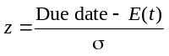
(Note: This might be a good time to discuss the difference between a continuous and a discrete probability distribution and the appropriate procedure for using a continuous distribution as an approximation to a discrete, if you have not already done so.)

Finish Time | z | Probability
One day early | –0.353 | 36.3
Two days early | –0.706 | 24.0
Three days early | –1.058 | 14.5
Four days early | –1.411 | 7.9
Five days early | –1.764 | 3.9*
Six days early | –2.117 | 1.7
Seven days early | –2.470 | 0.7
*The appropriate procedure for using the normal distribution gives 3.0%—roughly a 30% difference.
There is, by the approximate procedure used, a 3.9% probability of finishing five days, or one week, early.
3. Shale Oil is considering increasing the budget to shorten the shutdown. How do you suggest the company proceed?
In order to shorten the shutdown, Shale Oil would have to determine the costs of decreasing the activities on the critical path. This is the vessel and column branch of the network, which is typically the longest section in a shutdown. The cost of reducing activity time by one time unit for each activity in this branch would have to be calculated. The activity with the lowest of these costs could then be acted upon. Perhaps the repairs to the vessels and columns could be expedited with workers from some of the other branches with high slack time. However, delivery on materials could be an overriding factor.

